Experiment No 2:

Aim : To study fundamentals of Inheritance
THEORY
Inheritance: The capability of a class to derive properties and characteristics from another class is called Inheritance. Inheritance is one of the most important feature of Object Oriented Programming.
Sub Class: The class that inherits properties from another class is called Sub class or Derived Class.
Super Class: The class whose properties are inherited by sub class is called Base Class or Super class.
Modes of Inheritance
- Public mode: If we derive a sub class from a public base class. Then the public member of the base class will become public in the derived class and protected members of the base class will become protected in derived class.
- Protected mode: If we derive a sub class from a Protected base class. Then both public member and protected members of the base class will become protected in derived class.
- Private mode: If we derive a sub class from a Private base class. Then both public member and protected members of the base class will become Private in derived class.
Types of Inheritance in C++
- Single Inheritance: In single inheritance, a class is allowed to inherit from only one class. i.e. one sub class is inherited by one base class only.
- Multiple Inheritance: Multiple Inheritance is a feature of C++ where a class can inherit from more than one classes. i.e one sub class is inherited from more than one base classes.
- Multilevel Inheritance: In this type of inheritance, a derived class is created from another derived class.
- Hierarchical Inheritance: In this type of inheritance, more than one sub class is inherited from a single base class. i.e. more than one derived class is created from a single base class.
- Hybrid (Virtual) Inheritance: Hybrid Inheritance is implemented by combining more than one type of inheritance. For example: Combining Hierarchical inheritance and Multiple Inheritance.
A special case of hybrid inheritance : Multipath inheritance:
A derived class with two base classes and these two base classes have one common base class is called multipath inheritance. An ambiguity can arrise in this type of inheritance.

There are 2 ways to avoid this ambiguity:
- Use scope resolution operator
- Use virtual base class
Avoiding ambiguity using scope resolution operator:
Using scope resolution operator we can manually specify the path from which data member a will be accessed
Avoiding ambiguity using virtual base class:
Virtual base classes are used in virtual inheritance in a way of preventing multiple “instances” of a given class appearing in an inheritance hierarchy when using multiple inheritances.
Virtual base class is used in situation where a derived have multiple copies of base class

Constructors in Derived Class:
If the base class has a constructors with some parameters than it is mandatory for derived class to invoke the constructors of base class As only derived class is instantiated. Hence all the constructors are called, else object wouldn't be constructed properly.
Base class constructors are always called in the derived class constructors. Whenever you create derived class object, first the base class default constructor is executed and then the derived class's constructor finishes execution.
We can explicitly mention to call the Base class's parameterized constructor when Derived class's parameterized constructor is called.
ContainerShip:
We can create an object of one class into another and that object will be a member of the class. This type of relationship between classes is known as containership or has_a relationship as one class contain the object of another class. And the class which contains the object and members of another class in this kind of relationship is called a container class.
The object that is part of another object is called contained object, whereas object that contains another object as its part or attribute is called container object.

[a] Write a C++ program to study implementation of Hierarchical form of Inheritance
#include<iostream>
using namespace std;
class Student{
private:
int id;
string name,dob;
protected:
void getdata()
{
int id;
string name,dob;
cout<<"enter name"<<endl;
cin>>name;
cout<<"enter id"<<endl;
cin>>id;
cout<<"enter dob"<<endl;
cin>>dob;
this->id=id;
this->dob = dob;
this->name = name;
}
void display()
{
cout<<"Name: "<<name<<" ID: "<<id<<" DOB:"<<dob<<endl;
}
};
class Medical:protected Student{

string college;
string currsemester;
string specialisation;
public :
void getdata()
{
Student::getdata();

string college;
string currsemester;
string specialisation;
cout<<"Enter College"<<endl;
cin>>college;
cout<<"Enter Semester"<<endl;
cin>>currsemester;
cout<<"Enter Specialisation"<<endl;
cin>>specialisation;
this->college = college ;
this->currsemester = currsemester;
this->specialisation = specialisation;

}
void display()
{
Student::display();
cout<<"college: "<<college<<" Current Sem : "<<currsemester<<" Specialisation:"<<specialisation<<endl;
}
};
class Arts:protected Student{
string college;
string currsemester;
string specialisation;
public:
void getdata()
{
Student::getdata();
string college;
string currsemester;
string specialisation;
cout<<"Enter College"<<endl;
cin>>college;
cout<<"Enter Semester"<<endl;
cin>>currsemester;
cout<<"Enter Specialisation"<<endl;
cin>>specialisation;
this->college = college ;
this->currsemester = currsemester;
this->specialisation = specialisation;

}
void display()
{
Student::display();
cout<<"college: "<<college<<" Current Sem : "<<currsemester<<" Specialisation:"<<specialisation<<endl;
}
};

class Engineering:protected Student{
protected:
string college;
string currsemester;
public:
void getdata(string college,string currsemester,string specialisation)
{
this->college = college ;
this->currsemester = currsemester;
}
void display()
{
Student::display();
cout<<"College: "<<college<<" Current Sem : "<<currsemester<<" in Engineering"<<endl;
}

};
class Mech:protected Engineering{
string branch,rollno,section;
public:
void getdata()
{
Student::getdata();
string rollno ,section;

cout<<"Enter college: "<<endl;
cin>>college;
cout<<"Enter semester: "<<endl;
cin>>currsemester;
branch = "Mechanical";
cout<<"Enter rollno: "<<endl;
cin>>rollno;
cout<<"Enter section: "<<endl;
cin>>section;
this->rollno = rollno;
this->section = section;

}
void display()
{

Engineering::display();
cout<<"Branch: "<<branch<<" rollno : "<<rollno<<" section: "<<section<<endl;
}

};
class Civil:protected Engineering{
string branch,rollno,section;
public:
void getdata()
{
string rollno ,section;
Student::getdata();
cout<<"Enter college: "<<endl;
cin>>college;
cout<<"Enter semester: "<<endl;
cin>>currsemester;
branch = "Civil";
cout<<"Enter rollno: "<<endl;
cin>>rollno;
cout<<"Enter section: "<<endl;
cin>>section;
this->rollno = rollno;
this->section = section;

}
void display()
{

Engineering::display();
cout<<"Branch: "<<branch<<" rollno : "<<rollno<<" section: "<<section<<endl;
}

};
class Computer:protected Engineering{
string branch,rollno,section;
public:
void getdata()
{
string rollno ,section;
Student::getdata();
cout<<"Enter college: "<<endl;
cin>>college;
cout<<"Enter semester: "<<endl;
cin>>currsemester;
branch = "Mechanical";
cout<<"Enter rollno: "<<endl;
cin>>rollno;
cout<<"Enter section: "<<endl;
cin>>section;
this->rollno = rollno;
this->section = section;

}
void display()
{
Engineering::display();
cout<<"Computer: "<<branch<<" rollno : "<<rollno<<" section: "<<section<<endl;
}

};
class ETC:protected Engineering{
string branch,rollno,section;
public:
void getdata()
{
string rollno ,section;
Student::getdata();
cout<<"Enter college: "<<endl;
cin>>college;
cout<<"Enter semester: "<<endl;
cin>>currsemester;
branch = "ETC";
cout<<"Enter rollno: "<<endl;
cin>>rollno;
cout<<"Enter section: "<<endl;
cin>>section;
this->rollno = rollno;
this->section = section;

}
void display()
{
Engineering::display();
cout<<"Branch: "<<branch<<" rollno : "<<rollno<<" section: "<<section<<endl;
}

};
int main()
{
int N;
cout<<"Enter the no of Students"<<endl;
cin>>N;
Arts *arts = new Arts[N];
Arts *ap =arts;
Medical *med= new Medical[N],*mp = med;
Mech *mech = new Mech[N],*mc = mech;
Civil *civil= new Civil[N],*cp = civil;
Computer *comp= new Computer[N],*cm = comp;
ETC *etc= new ETC[N],*ep=etc;
int a,m,me,cv,et,co;
a=m=me=cv=et=co=0;
while(1)
{
int c;
cout<<"1- Arts"<<endl;
cout<<"2- Medical"<<endl;
cout<<"3- Engineering"<<endl;
cout<<"4-Display everything"<<endl;
cout<<"5-Exit"<<endl;
cin>>c;
switch(c)
{
case 1:

//
//arts[a] = new Arts();

arts->getdata();
arts++;
a++;
break;
case 2:

med->getdata();
med++;
m++;
break;
case 3:
char ch;
cout<<"a- Computer"<<endl;
cout<<"b- Civil"<<endl;
cout<<"c- Mechanical"<<endl;
cout<<"d-ETC"<<endl;
cin>>ch;
switch(ch)
{
case 'a':

comp->getdata();
comp++;
co++;
break;
case 'b':

civil->getdata();
civil++;
cv++;
break;
case 'c':

mech->getdata();
mech++;
me++;
break;
case 'd':

etc->getdata();
etc++;
et++;
break;
}
break;
case 4:
cout<<"\t\t\t\tDISPLAY"<<endl;
if(a>0)
cout<<"\t\tArts"<<endl;
for(int i=0;i<a;i++)
{
cout<<"--------------------------------------------------------------------------------"<<endl;

(ap+i)->display();
cout<<"--------------------------------------------------------------------------------"<<endl;
}

if(m>0)
cout<<"\t\tMedicals"<<endl;

for(int i=0;i<m;i++)
{
cout<<"--------------------------------------------------------------------------------"<<endl;

(mp+i)->display();
cout<<"--------------------------------------------------------------------------------"<<endl;
}

if(cv>0||co>0||me>0||et>0)
cout<<"\t\tEngineering"<<endl;
if(co>0)
cout<<" \t\t\t Computer"<<endl;
for(int i=0;i<co;i++)
{
cout<<"--------------------------------------------------------------------------------"<<endl;

(cm+i)->display();
cout<<"--------------------------------------------------------------------------------"<<endl;

}

if(cv>0)
cout<<" \t\t\t Civil"<<endl;
for(int i=0;i<cv;i++)
{
cout<<"--------------------------------------------------------------------------------"<<endl;

(cp+i)->display();
cout<<"--------------------------------------------------------------------------------"<<endl;

}

if(me>0)
cout<<" \t\t\t Mechanical"<<endl;
for(int i=0;i<me;i++)
{
cout<<"--------------------------------------------------------------------------------"<<endl;

(mc+i)->display();
cout<<"--------------------------------------------------------------------------------"<<endl;

}

if(et>0)
cout<<" \t\t\t ETC"<<endl;
for(int i=0;i<et;i++)
{
cout<<"--------------------------------------------------------------------------------"<<endl;

(ep+i)->display();
cout<<"--------------------------------------------------------------------------------"<<endl;

}

break;
default:
exit(0);

}
}

}

OUTPUT:
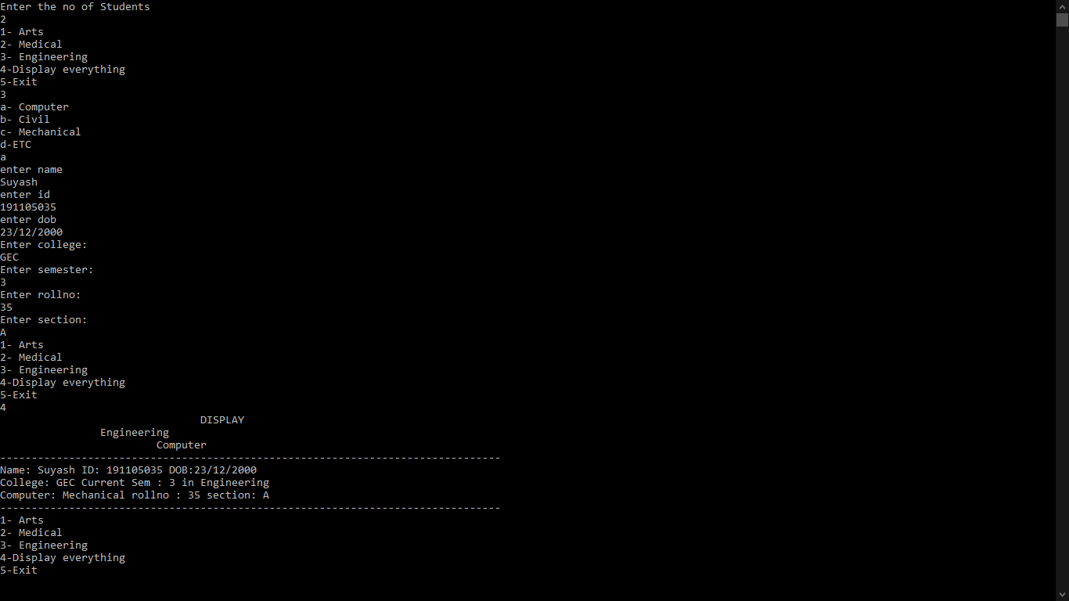

[b] Write a C++ program to study implementation of Hybrid form of Inheritance(Virtual Base Class)
#include<iostream>
using namespace std;
class Student{
int id;
string name,clas;
public:
void getdata()
{
cout<<"Enter name"<<endl;
cin>>name;
cout<<"Enter id"<<endl;
cin>>id;
cout<<"Enter class"<<endl;
cin>>clas;
}
void display()
{
cout<<"Name: "<<name<<" Id: "<<id<<" Class: "<<clas<<endl;
}
};
class Sports:public virtual Student{

protected:
int Smarks;
public:
void getdata()
{
cout<<"Enter Sports marks"<<endl;
cin>>Smarks;
}
void display()
{
cout<<"Sports MArks: "<<Smarks;
}
};

class test:public virtual Student{
protected:
float sub[6];
public:
void getdata()
{
cout<<"Enter 6 subjects marks"<<endl;
for(int i=0;i<6;i++)
cin>>sub[i];
}
void display()
{
cout<<"Subject marks are"<<endl;
for(int i=0;i<6;i++)
cout<<"\t"<<sub[i];
cout<<endl;
}
};
class result:public test,public Sports{
float mainresult;
public:
void calculateres(){
mainresult=0;
for(int i=0;i<6;i++)
mainresult+=sub[i];
mainresult +=Smarks ;
mainresult= (mainresult/615)*100;
}
void getdata()
{
Student::getdata();
test::getdata();
Sports::getdata();
}
void display()
{
Student::display();
Sports::display();
cout<<"\nResult is: "<<mainresult<<endl;

}
};
int main()
{
int n;
cout<<"Enter no of students"<<endl;
cin>>n;
result *r = new result[n];

for(int i=0;i<n;i++)
{
r[i].getdata();
r[i].calculateres();
}
for(int i=0;i<n;i++)
{
cout<<"-----------------------------------------------"<<endl;
r[i].display();
cout<<"-----------------------------------------------"<<endl;
}

}
OUTPUT:

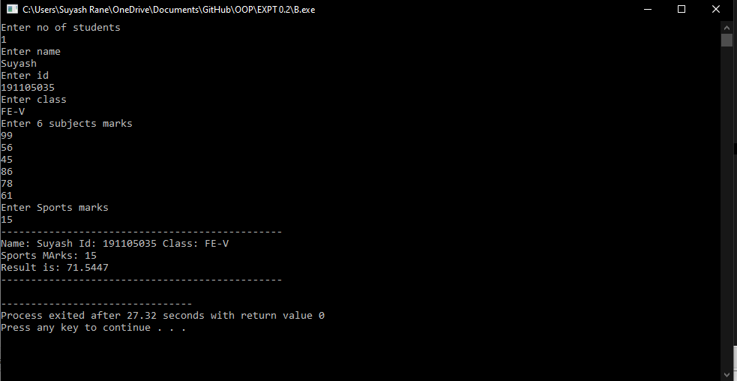

[c] Write a C++ program to study concept of constructors in derived classes
#include<iostream>
using namespace std;
class Sum;
class alpha{
int a;
float b;
protected:
alpha(int a,float b)
{
cout<<endl<<"Alpha Constructed"<<endl;
this->a = a;
this->b = b;
}
void display()
{
cout<<endl<<"ALPHA"<<endl;
cout<<"\ta :"<<a<<"\tb : "<<b<<endl;
}
~alpha()
{
cout<<"ALPHA DESTROYED"<<endl;
}
};

class beta:protected alpha{
int a;
double b;
protected:
beta(int a,double b,int c,float e):alpha(c,e)
{
cout<<endl<<"Beta Constructed"<<endl;
this->a = a;
this->b = b;
}
~beta()
{
cout<<"Beta DESTROYED"<<endl;
}
void display()
{
cout<<endl<<"BETA"<<endl;
cout<<"\ta :"<<a<<"\tb : "<<b<<endl;
}
};
class Sum{
int a,b,c,f;
float d;
double e;
public:
Sum(int a,int b,float d,double e,int c,int f)
{
cout<<endl<<"SUM Constructed"<<endl;
this->a = a;
this->b = b;
this->c = c;
this->d = d;
this->e = e;
this->f = f;
}
~Sum()
{
cout<<"SUM destroyed"<<endl;
}
void display(){
cout<<endl<<"SUM = "<<(a+b+c+d+e+f)<<endl;
}
};
class Gamma:protected beta //Multilevel Inheritance
{
int a;
float b;
Sum s; //Containership
public:
Gamma(int a, int b,int c,float d,int e,double f):beta(c,d,e,f),s(a,b,d,f,e,c) //Constructors for mutiple Inheritance are called in order they are derivrd
{
cout<<endl<<"Gamma Constructed"<<endl;
this->a = a;
this->b = b;
}
~Gamma()
{
cout<<"GAMMA DESTROYED"<<endl;
}
void display()
{
alpha::display();
beta::display();

cout<<endl<<"GAMMA"<<endl;
cout<<"\ta :"<<a<<"\tb : "<<b<<endl;
s.display();
}
};

int main()
{
cout<<"Below is an exmaple of Use on constructors and order of execution of "<<endl<<"\t\t Constructors in Multilevel Inheritance along with Containership :"<<endl;
Gamma g(1,2,3,4,5,6);
g.display();

}

OUTPUT:

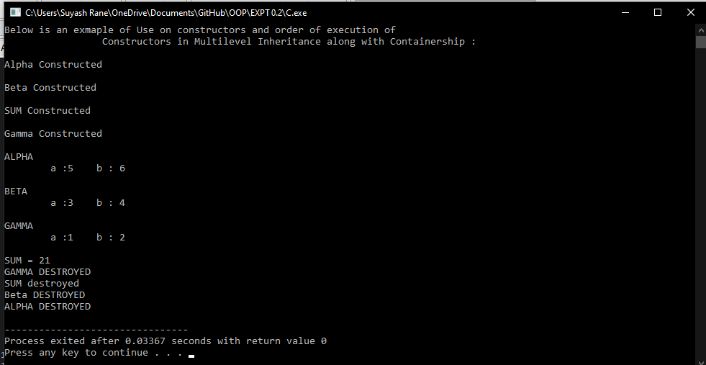

CONCLUSION:
Inheritance Allows us to reuse the code written in base class to derive
The member functions of a derived class can directly access only the protected and public data. However, they can access the private data through the member functions of base class.
Multipath Inheritance may lead to duplication of inherited members from a ‘grandparent’ base class. This may be avoided by making the common base class virtual base class.
In multiple inheritance the base classes are constructed in the order in which they appear in the declaration of the derived class.
In multilevel inheritance, the constructors are executed in the order of inheritance.

